How to update Law Firm 500 winners on website

Must update the summary list e.g., <https://lawfirm500.com/2019-award-honorees/> and the individual winner profile pages, e.g., <https://lawfirm500.com/2019-honoree-atlanta-divorce-law-group/>

For both use spreadsheet “builder-lf500-winner-website.xlsx”. You’ll want to update the winner data but **be careful not to overlay the calculated/edited columns.**

# Updating Summary

It’s an html table in the page content so just replace the specific rows that hold the names:

1. Search page for any mentions of previous year, e.g. 2018 and update them
2. Replace/modify the top header image due to year change.
3. Update winners list table
   1. Copy spreadsheet and save appending year: builder-lf500-winner-website-YYYY.xlsx
   2. Use spreadsheet columns W-AC
   3. In “Law Firm Name” replace & with and
   4. For “slug” column paste in firm name then manually do search/replaces:
      1. Replace space to dash (-)
      2. No regexp so one at a time replace $?’”/&_.,(){}[] to a dash  
         Note that ? will match everything so use “?”
      3. Replace “-----” to “-“ then do 4 dashes, then 3, then 2
   5. For “escaped description” replace ‘ with \’
   6. Copy the updated columns/rows that make up the html table
   7. Paste the updates into the winners list table on page
   8. Save and test.

# Updating Individual Winner Pages (posts)

A little more complicated.

## Export Post Format

1. Create dummy post with placeholders, or just use <https://lawfirm500.com/2019-lf500-test-winner/>. The placeholders are important: %NAME%, etc.  
   Don’t forget to update the category to reflect current year.
2. Update the post to change any year mentions, plus update/replace the badge image.
3. Export the post using WP All Export
   1. Create new export modeling “WP_Query Export - 2019 October 02 14:09”:
      1. Use WP_Query 'post_type'=>'post', 'p'=>'47718' or the post ID from your dummy post
      2. 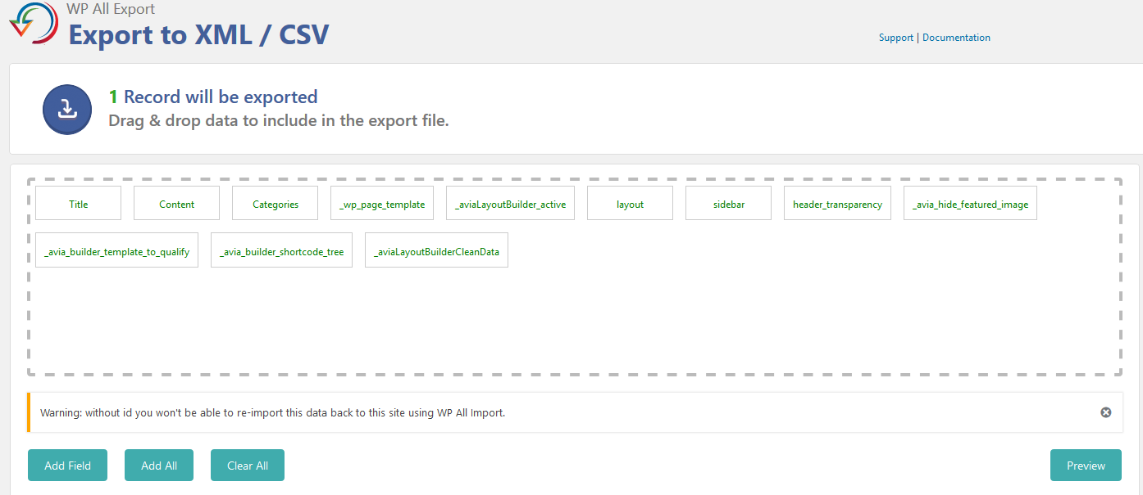Use these settings:

slug

* + 1. And choose Export Type XML at bottom of same page.
  1. Export the post

## Create Post Template Files

The XML post export is used to create the XML to input the new winners posts into the site.

It is split into 3 pieces: header, content, and trailer. The file names are at top of JS script.

1. The XML header file should not need to change: lf500-winner-post-formatted-header.xml
2. The XML trailer file should not need to change: lf500-winner-post-formatted-trailer.xml
3. Strip out the header and trailer from the exported file and what remains is the post content file: lf500-winner-post-formatted-content.xml (or -YYYY.xml if you prefer).

## Import Winner Data into JS Script

Use the spreadsheet columns N-V to create the array of objects which represents the winners.

1. Because data will be loaded as JS key/value, must escape any quotes. Easiest is to search/replace double quote to single, then replace single quote with escaped one using backslash quote (\’).
2. Escape the name and descriptions columns.
3. Visually scan the “website with protocol” column for any issues: only http:// or garbage in the field.
4. Copy the cols/rows and paste into “winners” var in the script. **\*REMOVE the last comma\***

## Execute JS Script

Should be no-brainer at this point. Just run it and troubleshoot if necessary. Most problems will be data issues.

## Import XML Posts into Site

Use output XML from the script to import into the site.

1. Title, content, categories, and slug are the usual.
2. The custom fields are easiest to add manually:
   1. Open custom fields pane
   2. Click in “name” field and select the field you want.
   3. Drag the custom field value from import file as usual.
   4. If custom field name does not appear when click in name box, then just drag the custom field from import into the name box then remove the { and } and [1].
3. Finish the import.
4. Go check out the posts.
5. <sigh> In 2020, the import process did not trigger the posts to be recognized by Avia/Enfold. The post looked like a generic LF500 post with default format.   
   Therefore, edit each post, click on “advanced editor” button, and save post.  
   TIP: you don’t need to wait for avia editor to load before hitting save. Just click then save.

Note that the export process may duplicate the page content. Looks like same page stacked upon itself. If that happens:

1. Edit the content section XML (lf500-winner-post-formatted-content.xml or -YYYY.xml)
2. Look for the dup section. In 2020 it was in the “_aviaLayoutBuilderCleanData” custom field.